EE5356 Project #7B Dr K.R.Rao

Geometric Mean Filter

1) For the degraded images given in project#7 Inverse and Wiener Filtering, apply the geometric mean filter for 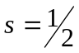 and show the restored images.
For , GMF is described by Eq. (8.71) /p.291
2) Repeat prob. 1) for 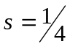
3) Repeat prob. 1) for 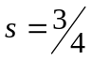

Comment on the restored images.

(Hint : for s=0, GMF Wiener filter, for s=1, GMF Inverse filter)

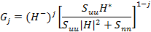 (8.70)

GMF
For j=1/2
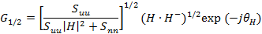 (8.71)

is phase of H()

Reference:
1) Textbook: Section 8.5/p.291 (Also new notes in chapter 8 on the course website)
2) Gonzalez and Woods’ Book: Section 5.10/p. 270

